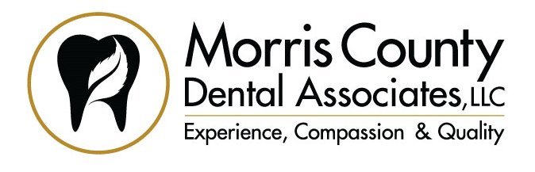
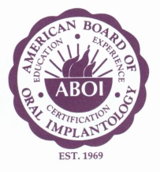
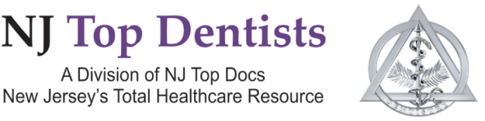
Ira Goldberg, DDS, FAGD, DICOI
15 Commerce Blvd, Ste. 201, Succasunna, NJ 07876 www.MorrisCountyDentist.com Ph: (973) 328-1225 Fax: (973) 328-7650

PRESS RELEASE
For Immediate Release

Local Dentist, Dr. Ira Goldberg, Teaches Other Dentists about Specialized Implants

PUERTO RICO (March 2020) – Dr. Ira Goldberg, a leading local authority on dental implants, spent time teaching other dental implant clinicians about a specialized dental implant known as a “pterygoid implant.” Over the past 7 months, Dr. Goldberg has been a participant in an advanced implant residency program in Puerto Rico, but was asked to guest-lecture about this implant technique.

“Dental implants are extremely commonplace, but it does take significant training to become proficient at both placement and restoration of these fixtures,” states Dr. Goldberg. “Most people who need dental implants do not require specialized implants, but there are situations where a patient cannot solve their dental problems with standard implants. Pterygoid implants can sometimes provide a solution. This is where advanced training and knowledge by a clinician can help patients.”

Dr. Goldberg has been one of the very few implantologists fortunate enough to have received training regarding pterygoid implants. As other dentists have heard about pterygoid implants, they have turned to Dr. Goldberg for training.

The program that Dr. Goldberg is both a participant and lecturer at in Puerto Rico is known as a “MaxiCourse.” A MaxiCourse is a 10-month in-depth curriculum dentists participate in when they wish to expand their knowledge regarding dental implants. There are programs worldwide, but what makes this Puerto Rico program so sought-after by experienced clinicians is the opportunity to learn non-traditional techniques that allow implantologists to offer a range of options when standard options are not suitable for their patients. Its this “above-and-beyond” quest for knowledge that patients truly benefit from.

Dr. Goldberg is a lecturer at other MaxiCourses. Some of the topics he shares with student implantologists include computerized guided surgery and principles of implant placement. Dr. Goldberg states, “It always an honor to work with dentists who want to further their talents with dental implants. These doctors are spending time away from their families and own offices to learn skills that will make them better dentists for the benefit of their patients.”

Dr. Goldberg holds many honors in the field of implant dentistry. He is a Diplomate of the American Board of Oral Implantology / Implant Dentistry, and a Fellow of the American Academy of Implant Dentistry, just to name a couple. Regarding his Diplomate status, there are only several hundred dentists world-wide that hold this distinction. It is an extremely grueling examination process.

Dr. Ira Goldberg is the owner of Morris County Dental Associates in Succasunna. He performs all phases of implant dentistry, and rarely are referrals required. For a free consultation, including a free 3-D scan (if necessary), please call his office at (973) 328-1225 or visit his website at www.MorrisCountyDentist.com
Diplomate of the American Board of
Oral Implantology / Implant Dentistry

